Laboratory WORK REPORT №3

«Active filter circuits design and simulation»

**Principles of Circuits**

Student:

Program of Automation

group AT

Name Surname：Li Xin





# Work purpose: to study parameters of Active Filters and basis of active filters circuits design

Goals:

1) Design an active filter on the basis of operational amplifier «Opamp_name»

2) Simulate active filter scheme and analyze dependencies of output voltage and resistor and capacitor values tolerance.

3) Analyze frequency domain of filter and determine approximation type and bandwidth

4) Analyze time domain of filter and which of test signals has passed in bandwidth

5) Analyze step response and H0/Hc value

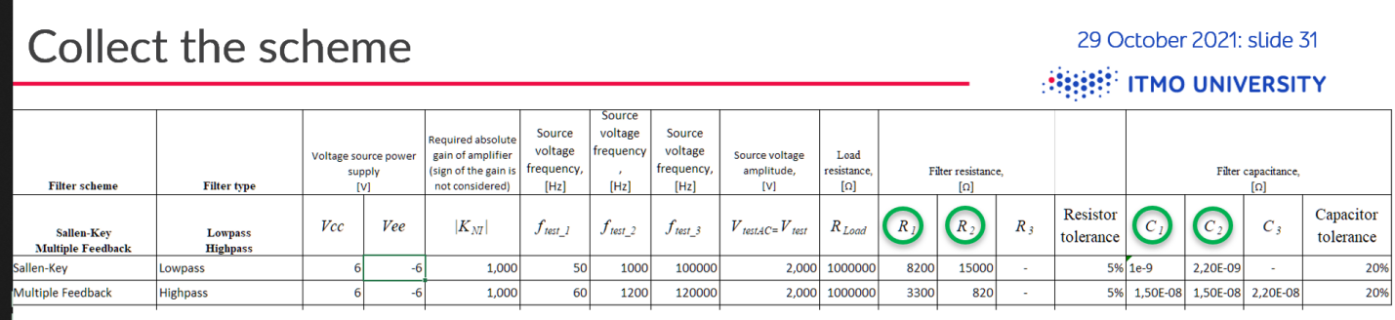

# Starting data

* **Required gain of amplifier $K_{NI}=$** 1
* **Required resistor tolerance $:{Tol}_{R}=$**5%
* **Required capacitor tolerance $:{Tol}_{C}=$**20%
* **Operational Amplifier :**
* **Voltage source power supply** Vcc $=6$ (V) / Vee $=−6$ (V)
* **Frequency for time domain simulation**

$f_{test1}=120$ (Hz)

$f_{test_{2}}=$ 2400 (Hz)

$f_{test_{3}}=$ 240000 (Hz)

* **Test signal voltage magnitude**

$V_{test_{AC}}=V_{test}=2$ (V)

$V_{step}=1$ (V) (for any variant)

* **Resistor parameters**

$R_{1}=10000$ (Ω)

$R_{2}=10000$ (Ω)

$R_{3}=5600$ (Ω)

$C_{1}=1$ (nF)

$C_{2}=2.7$ (nF)

$C_{3}=−$ (F)

$R_{Load}=$ 1000000 (Ω)

* **Amplifier scheme Multiple feedback:**
* **Filter type: Low-pass**

# Simulation

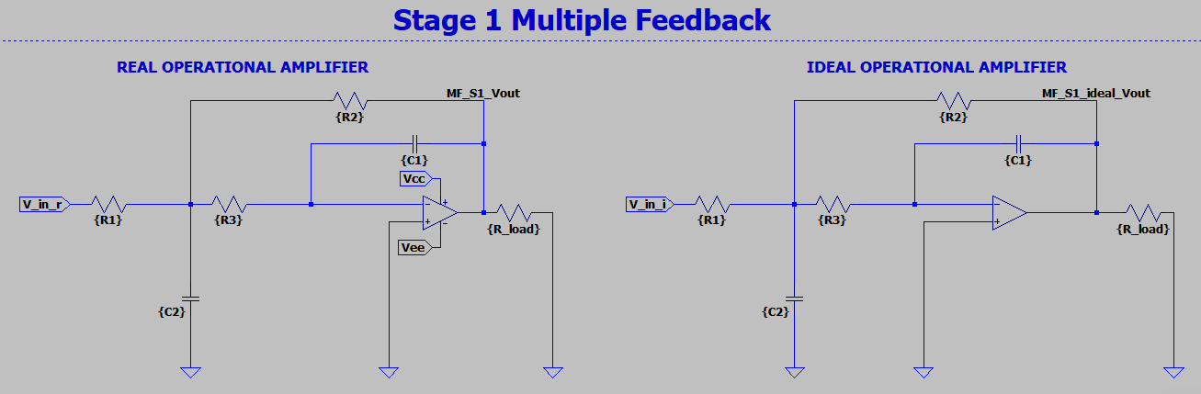

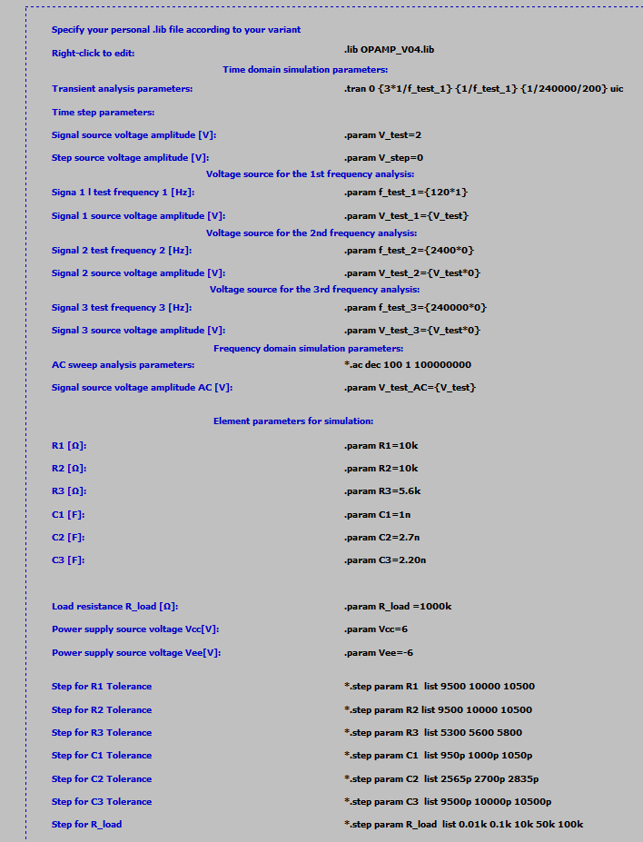

Figure 3.1 – Multiple Feedback Low-Pass filter

## Filter evaluations:

## Time domain simulation results

### $f_{test_1}=120$ (Hz)

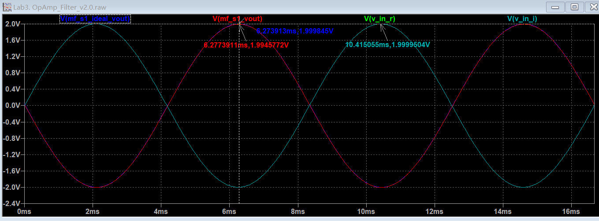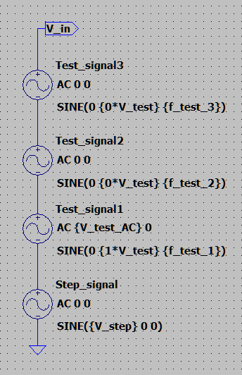

Figure 3.2 – Input and output voltages of ideal and real operational amplifiers active filters

$f_{test_1}=$ $120$ (Hz)

### $f_{test_2}=2400$ (Hz)

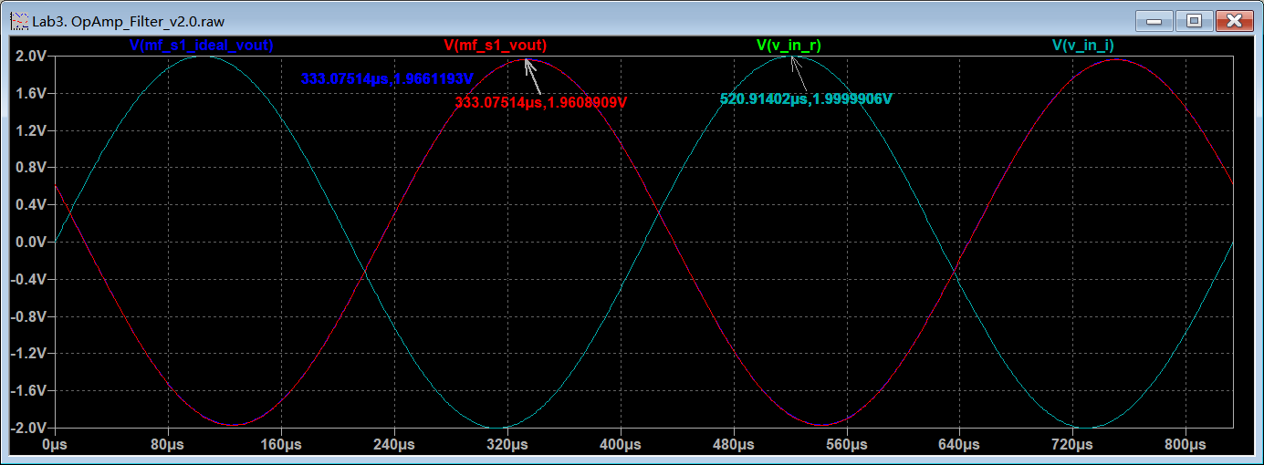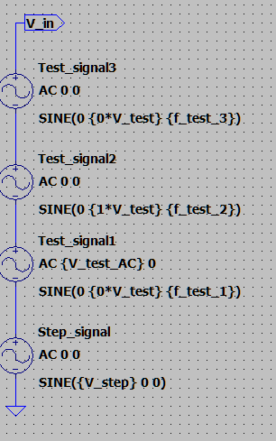

Figure 3.3 Input and output voltages of ideal and real operational amplifiers active filters

$f_{test_{2}}=$ 2400Hz,

### $f_{test_3}=240$ (kHz)

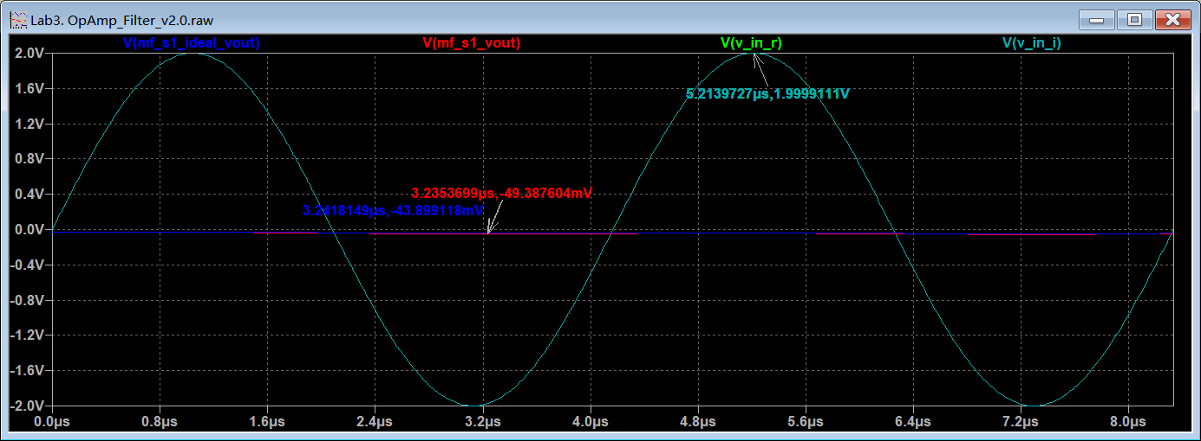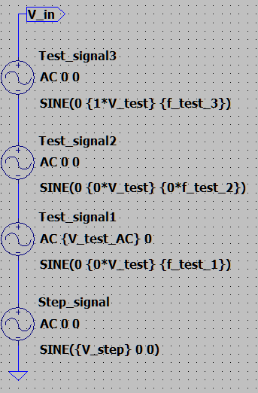

Figure 3.4 – Input and output voltages of ideal and real operational amplifiers active filters

$f_{test_3}=$ $240$ (kHz)

$Step response check$

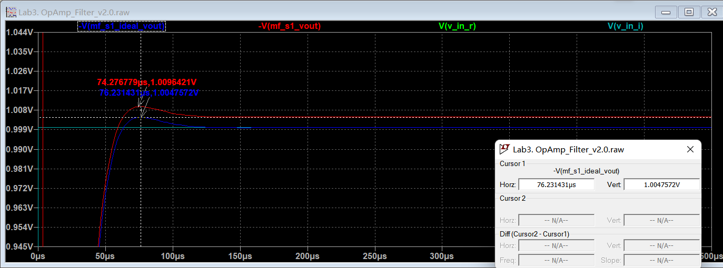

Figure 3.5 – Step response of ideal and real operational amplifiers active filters

## Frequency domain simulation results

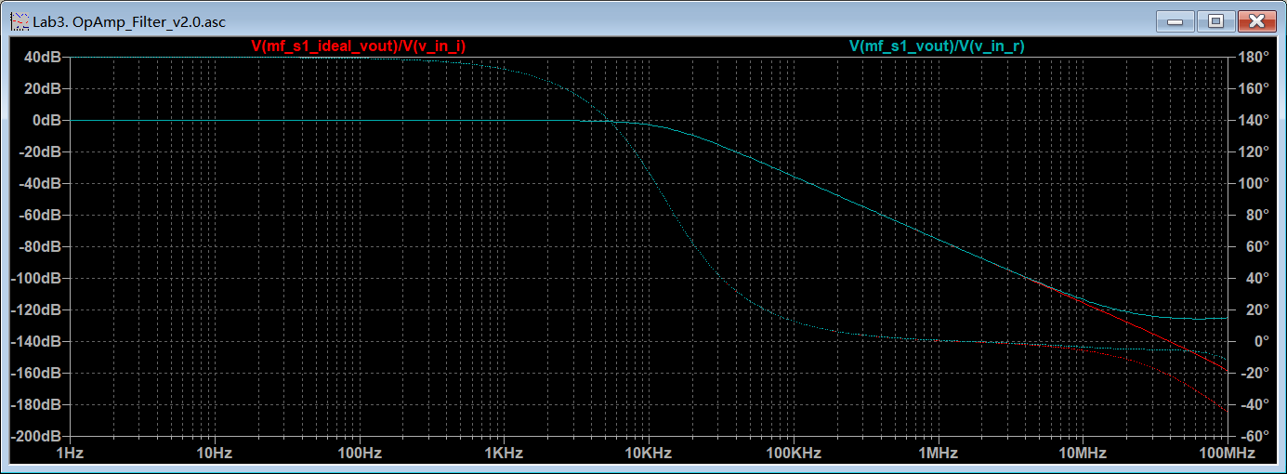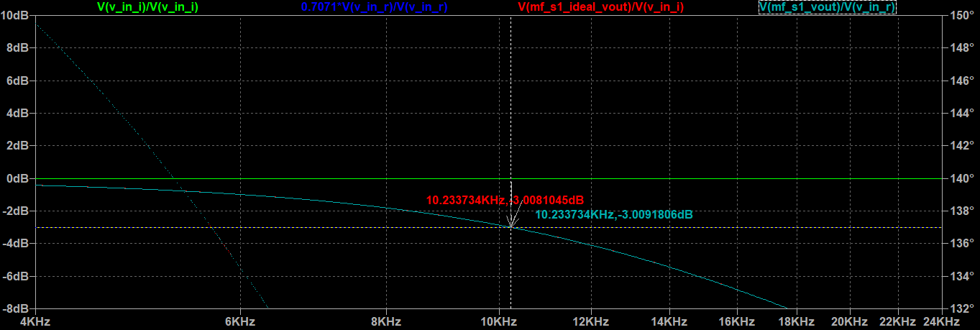

Figure 3.6 – Input and output voltages of ideal and real operational amplifiers active filters

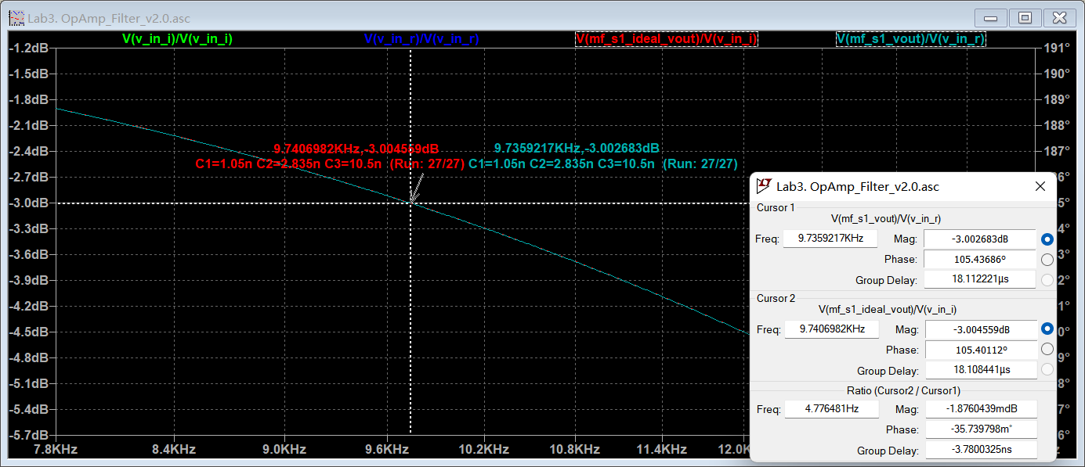

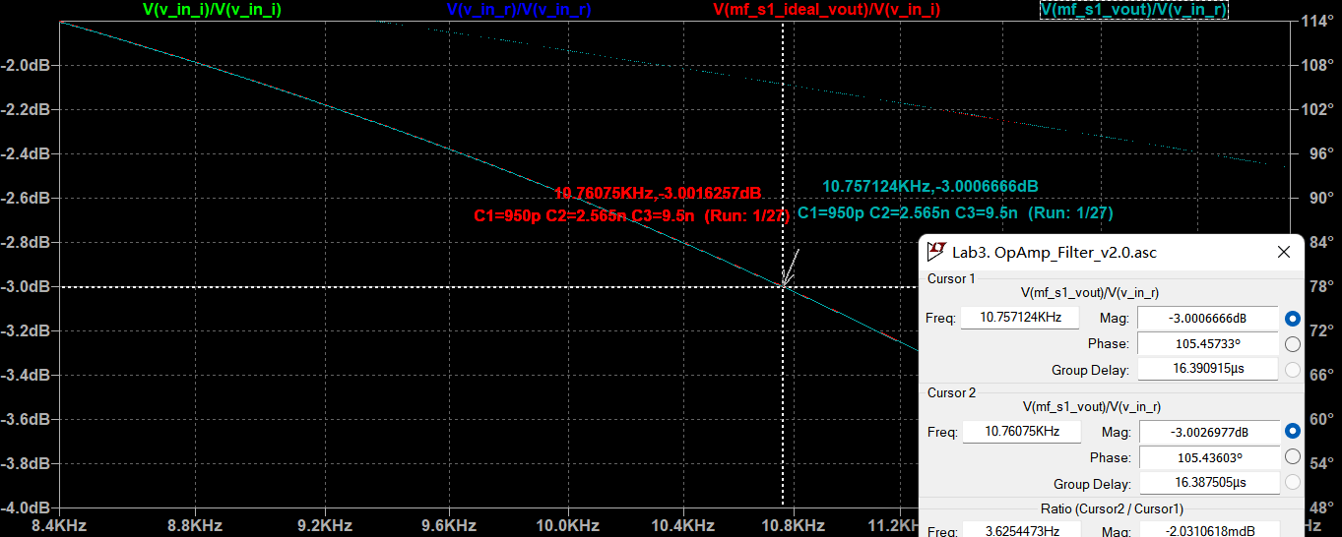

Figure 3.7 – Capacitor tolerance effect on the filter parameters

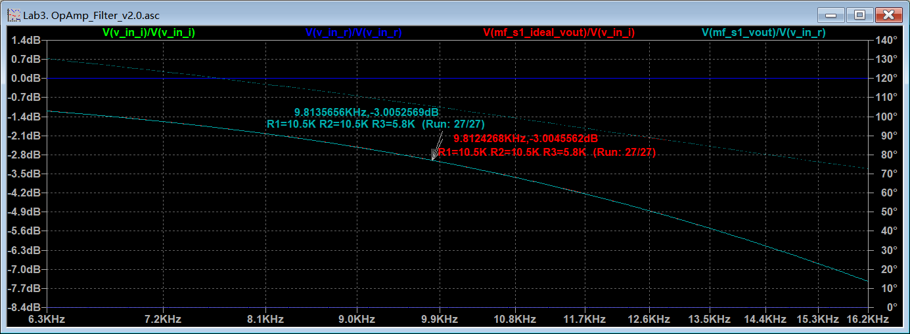

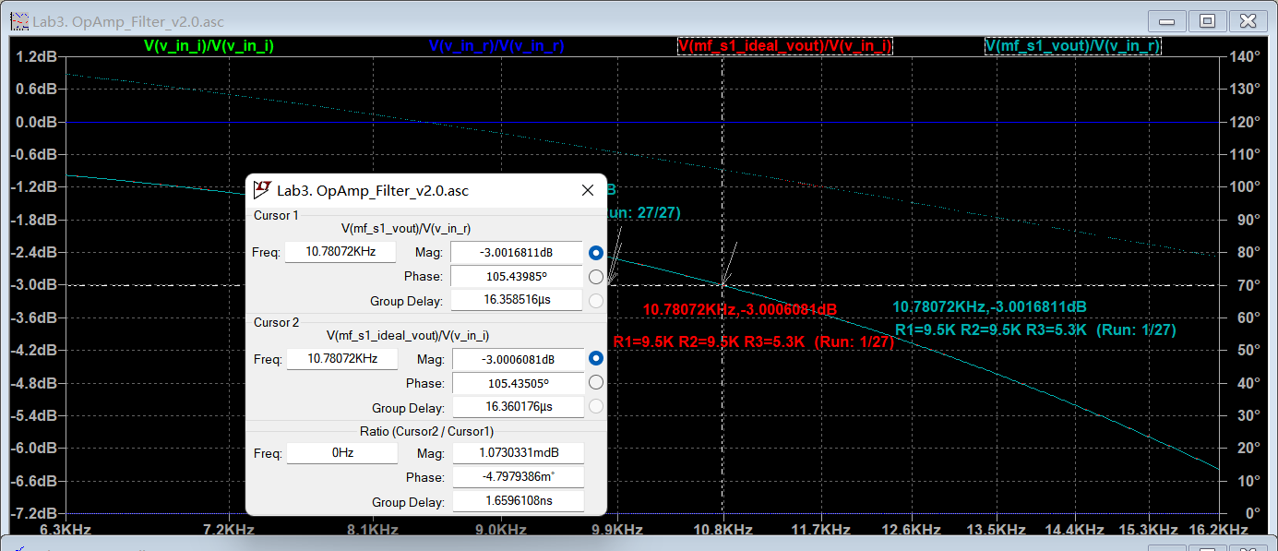

Figure 3.8 – Resistor tolerance effect on the filter parameters

Table 1. Parameters of the filter

|  |  |  |  |
| --- | --- | --- | --- |
|  | Description | Filter type: lowpass Butterworth | |
| nominal | tolerance range |
| R1, (Ω) |  | 10000 | 9500-10500 (±5%) |
| R2, (Ω) | 10000 | 9500-10500 |
| R3, (Ω) | 5600 | 5300-5800 |
| С1, (nF) | 1 | 950p - 1050p |
| С2, (nF) | 2.7 | 2565p - 2835p |
| С3, (nF) | - | - |
| fc | Frequency at -3dB gain level of the passband (resistor tolerance), fig. 3.8 | 10.234Khz | 9.812-10.78kHz |
|  | Frequency at -3dB gain level of the passband (capacitor tolerance) fig. 3.7 | 10.234kHz | 9.74-10.76kHz |
| K | Gain | -1 | -0.9814 |
| H0/Hc | Gain ripple in the passband (-3.0dB) | 0.707 | 2.887 dB (3-0.113） |

# Conclusions

Which filter type were used?

**Amplifier scheme** **Multiple feedback:**

**Filter type: Low-pass**

What was the bandwidth?

**Resistor tolerance: 9.812-10.78kHz  
Capacitor tolerance: 9.74-10.76kHz**

Which test signals (test 1, 2 or 3) were passed the filter?

**Test1**

What was the maximum/minimum gain relation in the passband?

1/0.707=1.414